

Game Design Document

Victor GANTER – 2926840

Melchior GARRIGUES – 2927207

Valentin FEREY – 2926392

Galdan MOULINNEUF – 2927686

Index

1. Game design
2. Summary
3. Gameplay
4. Technical
5. Rules of play
6. Mechanics
7. Dynamics/Advanced rules
8. Level design
9. Setting
10. Objects
11. Challenges
12. Development
13. Conclusion

I - Game Design

Summary

In **Goldrush**, a game of military strategy, you are battling to conquer the world.

To win, you must attack your opponents and gain their territories, defend yourself on all fronts, and gather resources such as Wood, Iron, Food and, of course, Gold.

This game is essentially based on strategy. The only luck you can get is when you’re mining Gold, the rest is up to you:

* Conquer the gold mines: You will earn more armies that way.
* Be on your guard, if your opponent creates units, they might attack you!
* Always be prepared for an opportunity, a single military unit can make the difference as much as a unit of gold.

Composition :

* 1x Board game
* 4x Dices for each player
* Resources: 50x cards of each
* Units: 30 units of each type and each colour for each player

Gameplay

There is two winning conditions in the game. You can either conquer all territories of the map or stock 30 units of Gold.

You can conquer territories by winning it in through a fight if the territory is occupied or just by placing at least one unit on it if it’s empty.

A player is out of the game when he no longer owns any territories.

If a territory finds itself not occupied - for example if a fight is a perfect draw -, the territory get back to it’s initial state and can be won just by placing a unit on it.

II - Technical

Rules of Play :

Each players gets 6 of each resources at the beginning of the game. At this point, they can create units as they want.

Then, all players roll the dice to determine the order. The player with the highest number will be the first to place his units (he will create the unit with the resources he have), then the player on his left will follow until all resources are spend.

Mechanics :

One Turn consist of 4 steps, in each steps all players play each after another, the 4 steps are:

* Gather resources and place workers
* Create units with the resources
* Fights With other players
* Move units

Each territory gives one resource of it’s own. Gold can only be obtained by rolling the dice.

*Workers and Resources :*

In this game, there are workers which helps gain resources and units that help conquer the game.

For each territory the player control, the player gain 1 resource (accordingly to the territory resource type), EXCEPT gold, who can be only be obtain with workers.

The number of workers is set to 3. You can place your workers anywhere in the map (workers are virtual units), you cannot place a worker on a gold territory that you don’t control. To get resources you have to roll the dice for each worker.

When you roll the dice on a territory:

1: No resources on that territory;

2 – 5: 1x resource of the type you’re in;

6: 2x resources of the type you’re in;

*Create units :*

There is three kind of units: Cavalry, Archery and Infantry. The resources needed for each is described in this table :

|  |  |  |  |
| --- | --- | --- | --- |
|  | Wood | Food | Iron |
| Cavalry | 0 | 2 | 1 |
| Archery | 2 | 1 | 0 |
| Infantry | 1 | 0 | 2 |

Units you create can go anywhere as long as the territory is yours.

*Fights:*

You can only fight a territory that’s adjacent to one of yours (only the units of this territory will be able to fight).

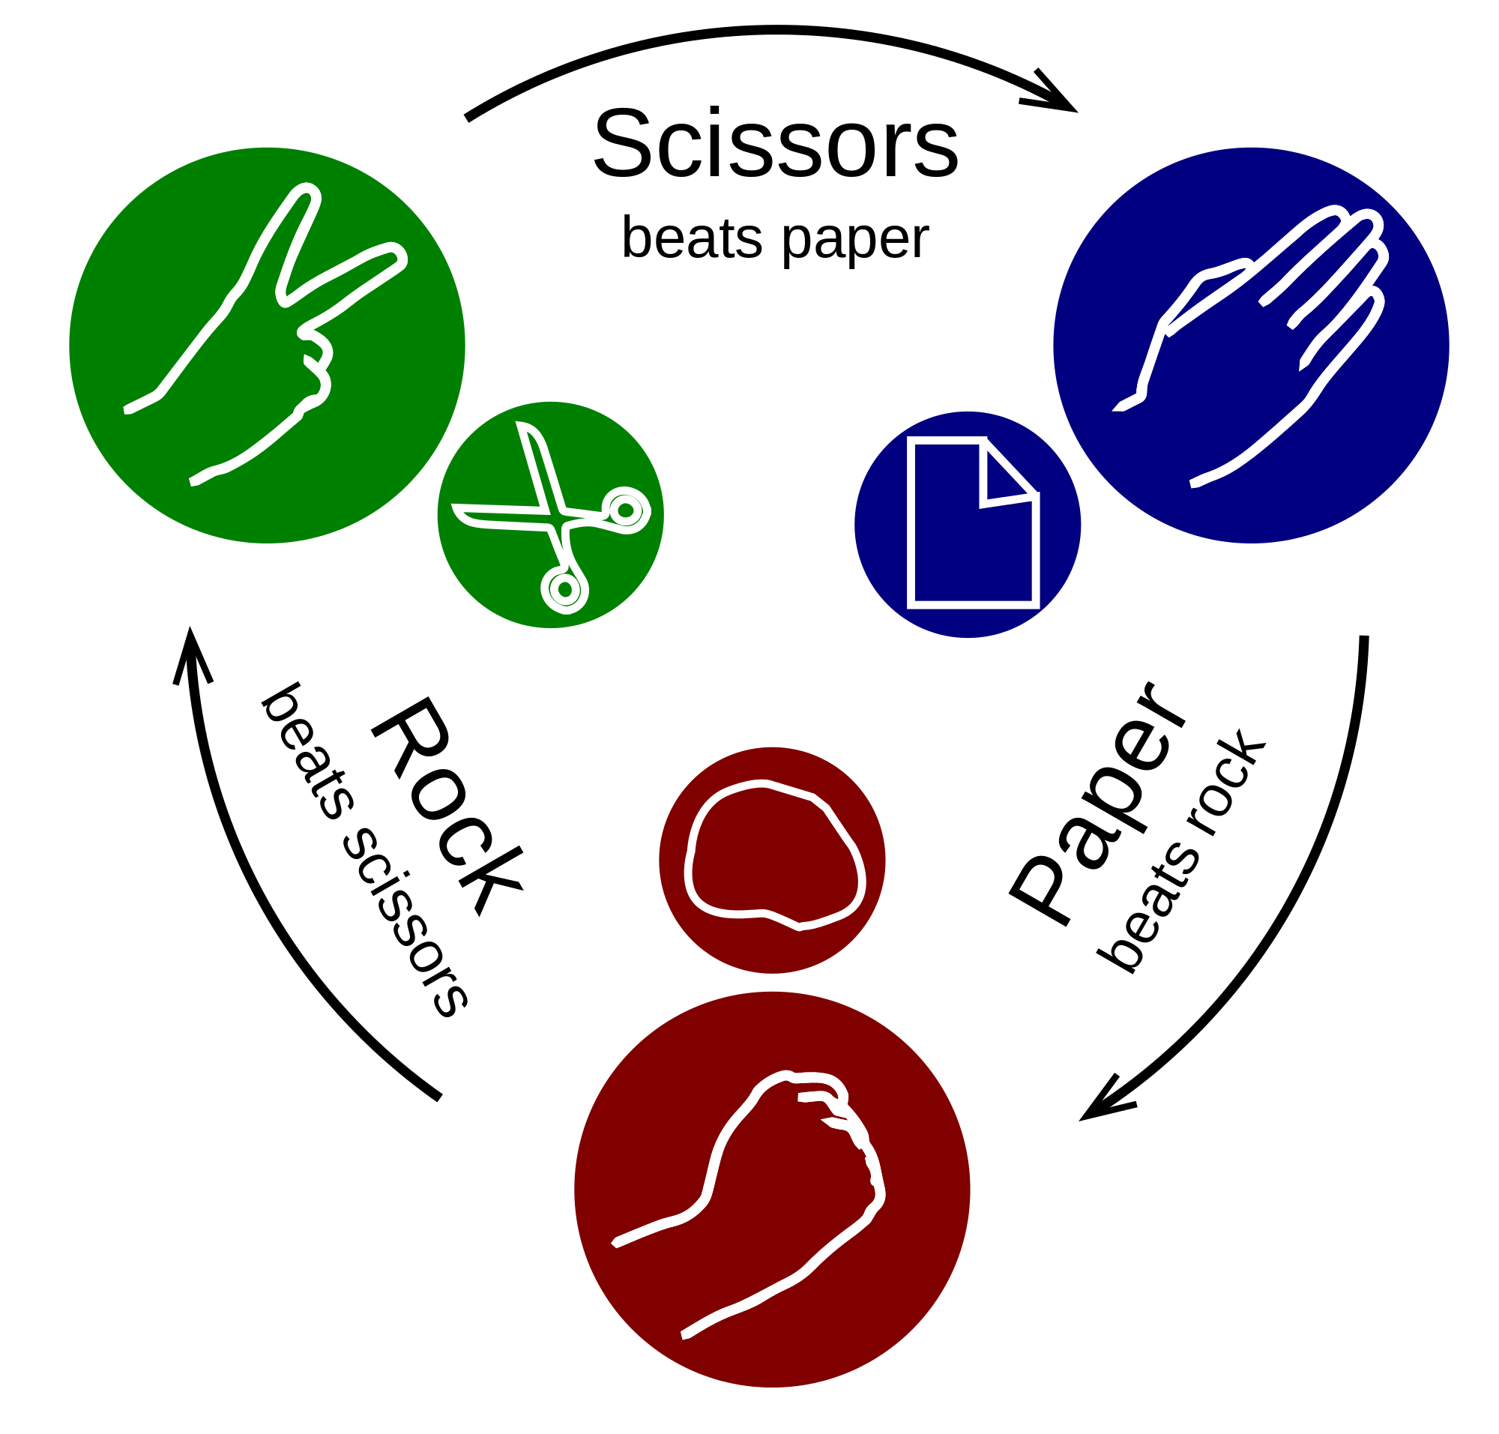

It’s the same principle of the game *“Rock Paper Scissors”.*

We have three type of units, and these units can only counter one type of unit. Like here, for example the Paper can beat the rock, but he’s being defeated by the Scissors.

Cavalry -> Infantry -> Archery -> Cavalry.

Fights are turn-by-turn based, the defender will always begin. The player chose a unit to attack an enemy’s one. When two units of the same type are fighting, the fight results in a draw and both units will be destroyed. The player can choose to use 1 gold to increase the power of one unit for the turn.

If the whole fight results in a draw, the territory is left unoccupied.

*Move units:*

You can move your units on your own territories and they must be adjacent.

III - Level Design

Setting

The game have multiple pieces, the main map, is one of the most important piece, it is composed of many territories in hexagonal shapes, and each territory has a resource type, on the map there is only 2 territories that have gold. This 2 specific territories are placed in the center of the map, to emphasize fights around this place.

The map in function of the number of players have differents sizes :

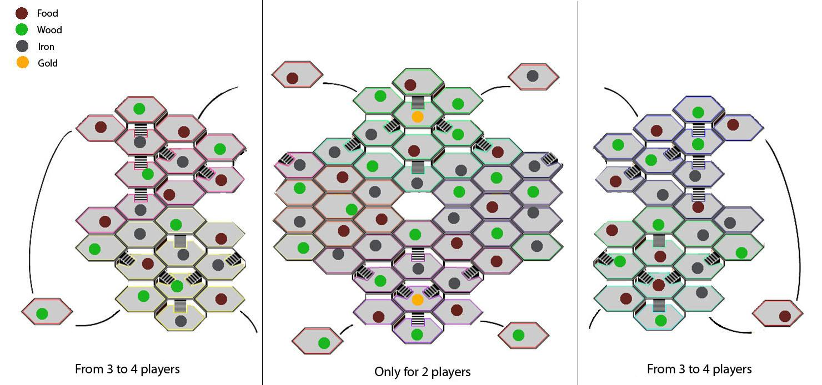

In the game there is also units cards, who are used by the player to show where their units are.

And ressources cards who represent the resources that each player have.

Objects

Here you can see the different cards to play with :

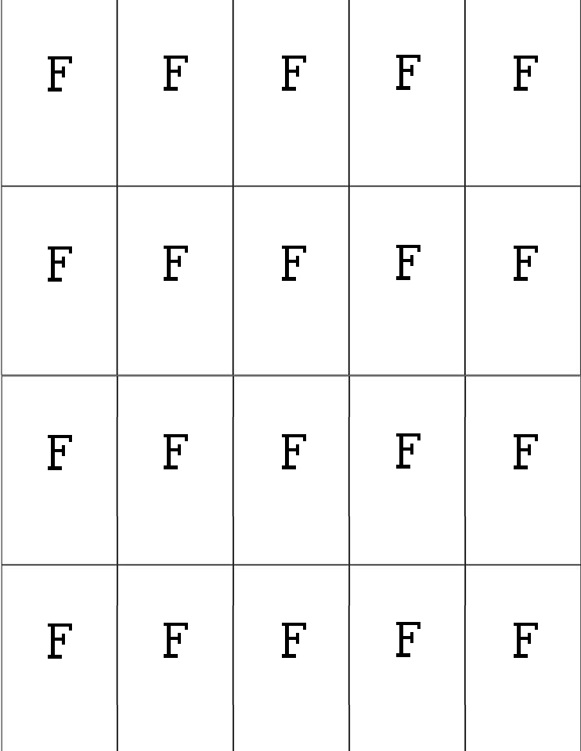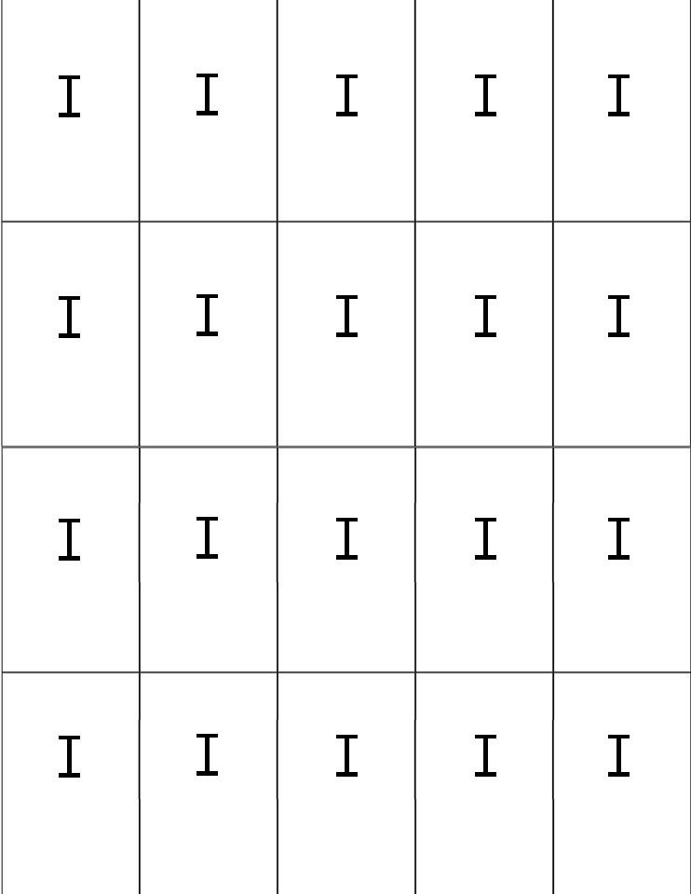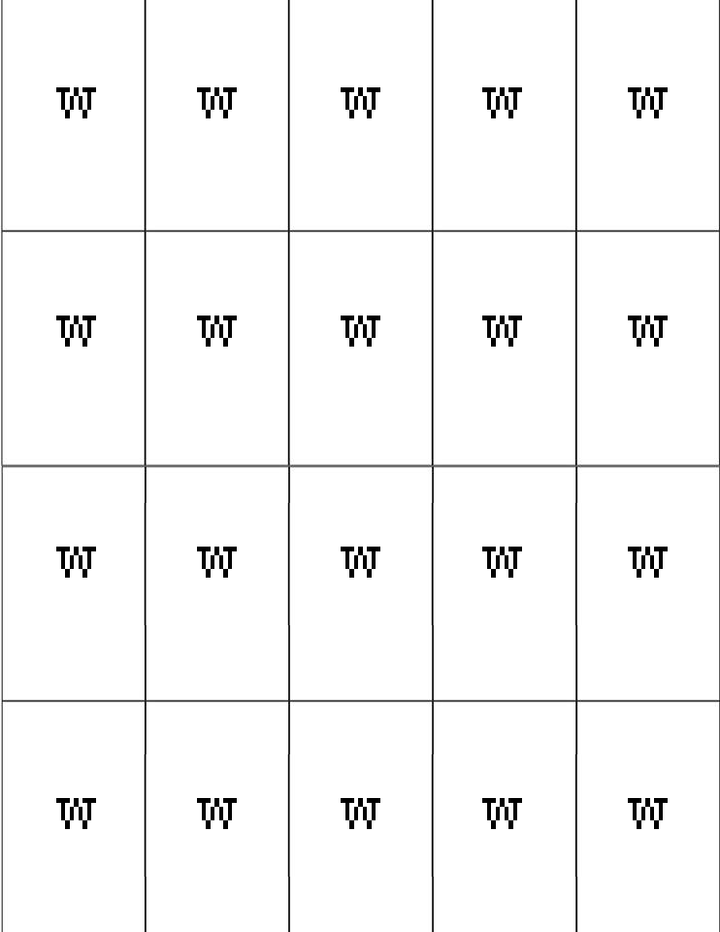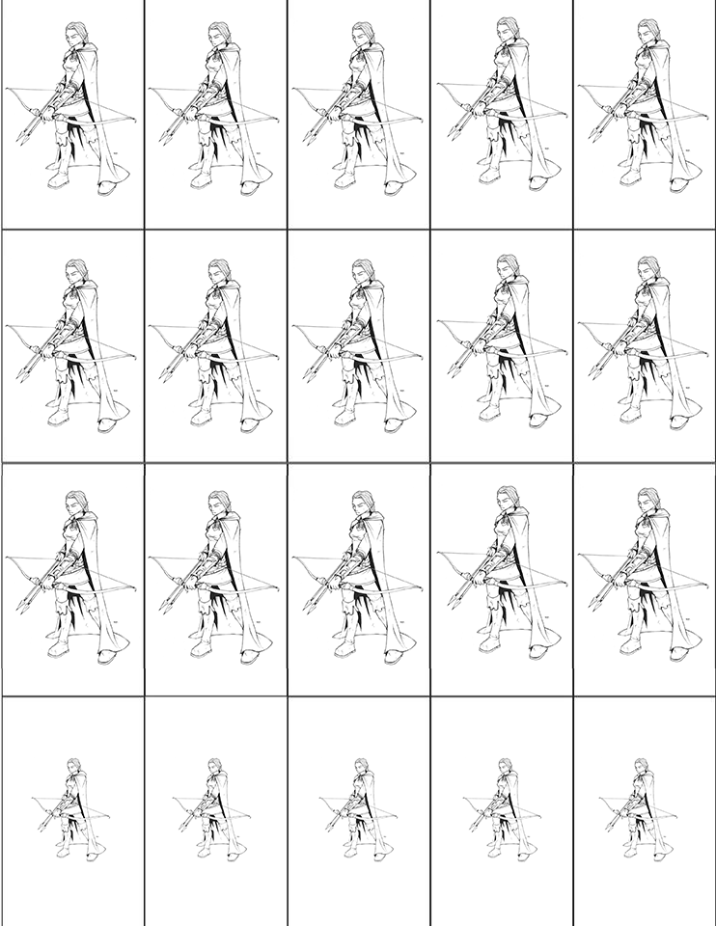

IV - Development

Gold Rush, take a lot of inspiration from risk, but add mechanics to make the core gameplay more interesting, more strategic. The fights have no random factor, and the fights are based on 3 types of units. Each unit beat another type in a rock-papers-scissors manner. We also introduce ressources, who give a different weight to each units, and introduce the resource deny strategy.

### 4.1 Early ideas & refining

The Early ideas introduces gold, who is a special resource. Gold can be traded for any other resource, and produce mercenaries.This give gold a lot of importance, and player must fight for it.

Since gold is very important territories who have gold, must be placed in strategic locations, in a way that they are easy to take, hard to defend. So the idea was not to place gold in corners but in the middle of zones, and can be attacked by multiple territories.

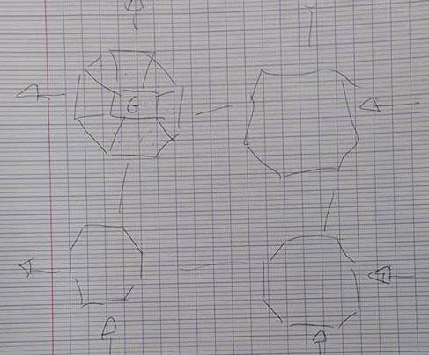

Here on this handmade shema, we can see ideas, how to make gold important.

We were thinking that each island can be self sufficient, providing each type of resources (to avoid players to be stuck without a certain type of resource).

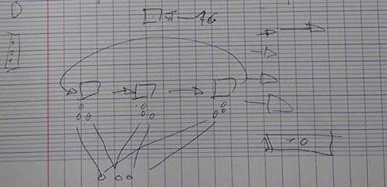

Here is another schema of how the different units will interact between each other, and how we produce them (what resources does they cost).

### 4.2 Early Prototypes

Instead of prototyping all the maps by ourself, we take a map on a risk website, and adjust it to our needs.

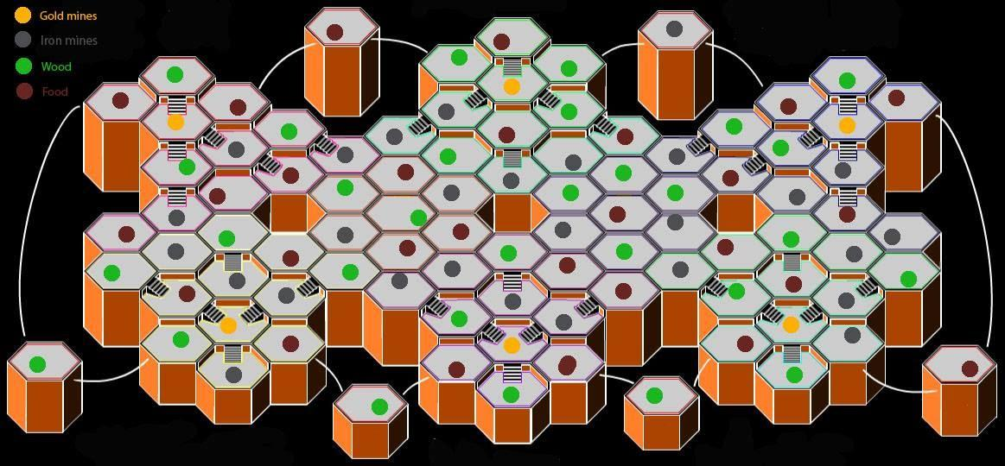

We put resources on each tile, add gold in center places, and try to balance resources, in the philosophy presented before (zones can be self sufficient). Units & resources templates were created:



After some thinking, we changed how the gold works, instead of buying mercenaries with it, gold instead boost units in fights. Gold has also become a winning condition.

Basics rules were put in place, to begin technical testing.

### 4.3 Refined Prototype

To address the issues finded in testing, we have made several changes to the game.

* Since expanding take time, we remove the conditions, that a player, to control a territory must leave at least one unit on it. Unit cost was also lowered, each units costing only of 2 types of resources, instead of 3.
* Fight System was completely reworked, instead of all units fight at the same time (who was confusing), we put in place a turn based system, where each player say which of his unit will attack, one of the other player unit. Taking into account the strength/weakness of his units.
* Gold territories was removed, only two gold territories are in the map now.
* To also make the game more dynamic, we reduced the workers to only 3, and change the way to earn resources. Now for each territory you control, you gain one resource of his corresponding type, Except gold. Workers now can be used to gain additional resources, but they are also the only way to gain Gold.

### 3.4 Last Prototype

* Gold Now can be stolen by the winner of a fight (one by win)
* Changed Map, Now there is 2 versions in function of the number of players



Here is an image of the new Map

### 4.5 Final testing Question & Feedback :

1. Did the rules are clear and easy to understand ?

*Yes the rule script was clear, we didn’t need to ask for help but just too many informations to keep in mind during the game so we always needed to refer to it.*

1. Did you get the strategic part of the game? Did you like it?

*Of course ! The strategic part is one of the funniest thing in this game, there is a lot of different way to win and the cool thing is that you don’t really need to focus on gold to win because if you take good resources and good armies it become easy to stole everything to your opponents.*

1. Did the game seems you balance?

*For the game we played it was, it was just a question of logic and strategy but maybe needed to be played few times more to answer this question*.

1. Did you find the costs of the resources too much or less important?

*I don’t know, sometimes at the beginning it was, it difficult to have a good army but after 5 or 6 rounds you can have all what you want so...*

1. Did you find the game too long?

*Yes a bit longer. Maybe because the strategy make us meditate a lot of time. And the prototype is not really playable because we always needed to take notes*.

1. Did you enjoy playing the game?

*At the beginning it really looked like boring. To well understand how to play, how to start it take too much time and if you’re not patient it become boring. But in fact after few rounds when you start the strategy and to well handle the game logic it become really interesting and fun.*

1. What did you think about the battles?

*The concept of the counter troops is quite good. Battles were balanced and you can have fun by doing yourself the animations. Seems correct in global.*

V - Conclusion

This is the area where you make any closing remarks that you wish to about the game. What would you like to see happen with it in the future. What were some particular difficulties that you had to or have to overcome?